NXT Studio
IoT Data Analytics Internship
Week 2 Assignment

Submitted By
Name: Saniya Syed
Course: B.Tech – CSE (INTERNET OF THINGS)
Collage: Jain (Deemed-to-be University)

Submitted To
NXT Studio

Internship Duration
12 Weeks

Assignment
Week 2 - Python for Data Analytics

Table of Contents:
- Variables and Data Types
- Loops
- Functions
- File Handling
- Exception Handling
- Introduction to NumPy

Program 1: Variables and Data Types
Aim:
To understand variables and different data types in Python.
Theory:
Variables are used to store data in Python. Common data types include int, float, string, and boolean.
Program: 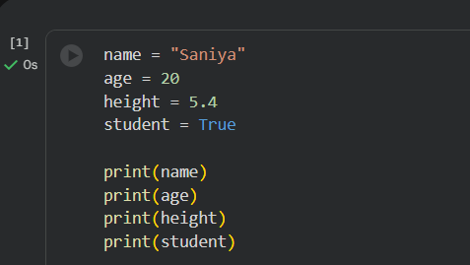
Output:
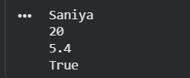
Conclusion: The program successfully demonstrates the use of variables and different data types in Python.
Program 2: Loops
Aim:
To understand the use of loops in python
Theory:
A loop is used to execute a block of code repeatedly. The for loop iterates over a sequence of values.
Program:
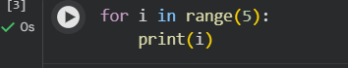
Output:
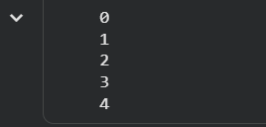
Conclusion: The program demonstrates the working of a for loop by printing numbers from 0 to 4.

Program 3: Functions
Aim:
To understand the use of functions in Python.
Theory:
A function is a reusable block of code that performs a specific task. Functions help make programs more organized and reduce code repetition.
Program:
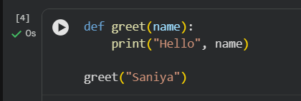
Output:
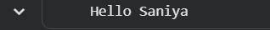
Conclusion: The program demonstrates how to create and call a function in Python.

Program 4: File Handling
Aim:
To understand file handling in Python.
Theory:
File handling allows a program to create, read, write, and modify files. Python provides built-in functions such as open(), write(), and read() for file operations.
Program:
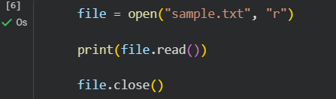
Output:

Conclusion: The program demonstrates how to write data to a file and read it using Python.

Program 5: Exception Handling
Aim:
To understand exception handling in Python.
Theory:
Exception handling is used to handle runtime errors without stopping the execution of the program. Python uses try and except blocks to catch and handle exceptions.
Program:
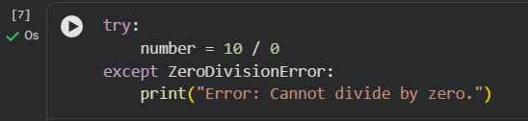
Output:
Conclusion: The program successfully demonstrates exception handling by catching a division-by-zero error.

Program 6: Introduction to NumPy
Aim:
To understand the basics of the NumPy library and perform simple array operations.
Theory:
NumPy is a Python library used for numerical computing. It provides support for arrays and mathematical operations, making data processing faster and more efficient.
Program:
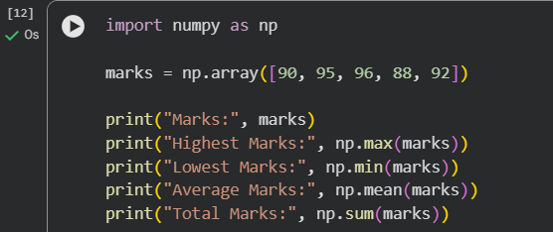
Output:
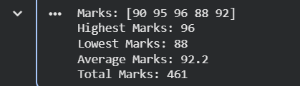
Conclusion: The program demonstrates how to create a NumPy array and calculate its average using the mean() function.

Conclusion:
During Week 2: Python for Data Analytics, I learned the fundamentals of Python programming, including variables and data types, loops, functions, file handling, exception handling, and the basics of the NumPy library. I successfully implemented and executed each program and understood their practical applications in data analytics.
References
Python Official Documentation – https://docs.python.org/3/⁠
NumPy Official Documentation –
https://numpy.org/doc/⁠

